Question 15:
Make a dictionary of five friends and their birthdays. Print each birthday.
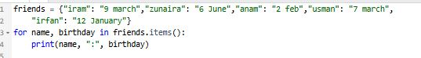
Output:
